**Project Design Phase-II**

**Data Flow Diagram & User Stories**

|  |  |
| --- | --- |
| Date | 15 October 2022 |
| Team ID | PNT2022TMID27784 |
| Project Name | Project - AI based discourse for Banking Industry |
| Maximum Marks | 4 Marks |

**Data Flow Diagrams:**

**DFD LEVEL- 0:**

1. 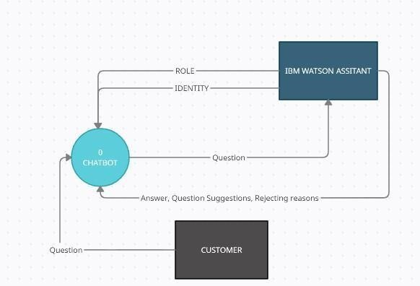The IBM Watson assistant has trained with identity,entites and roles and given to chatbot
2. The question in chatbot are given to ibm assistant
3. The suggestions,answers,reasons for the questions are given by assistant
4. Cutomers are the one who gives the question

**DFD LEVEL- 1**

1. 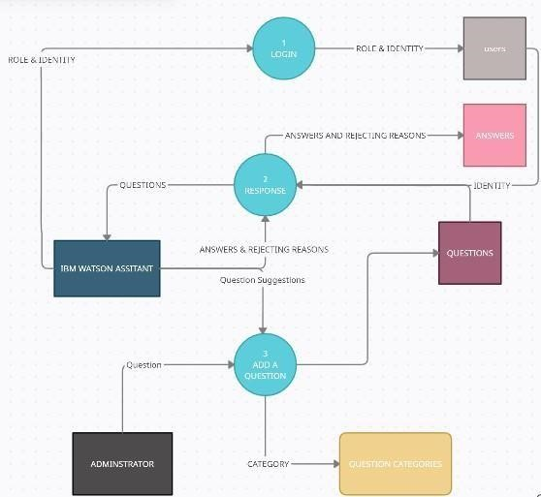there are two actors in the Chatbot system: a IBM Watson Assistant and an administrator. The IBM Watson Assistant is tasked to provide questions and answers to the system as explained previously.
2. Meanwhile, the administrator’s responsibility is to provide initial questions.
3. In the DFD level 1, the Chat-bot system is detailed to three subprocesses: (1) provide role and identity, (2) response to a question, and (3) add a question.
4. The first and second subprocesses belong exclusively to the IBM watson assistant, while the third process is shared between the IBM watson assistant and the administrator.
5. The first subprocess stores the role and identity of the IBM watson assistant and stores them in the users' table.
6. The second subprocess handles the process where the IBM watson assistant answer or reject the question.
7. Whether it is an answer or a rejecting reason, the data is stored in the answer table flagged with different statuses.
8. The third sub-process is responsible to receive question input from both the IBM watson assistant and administrator in different cases: input question suggestion for the IBM watson assistant and add initial questions for the administrator.
9. This subprocess takes a question as an input and store the question and question category in their respective table.
10. The question category explains whether the question is provided by the IBM watson assistant or the administrator.

**User Stories:**

|  |  |  |  |  |  |  |
| --- | --- | --- | --- | --- | --- | --- |
| **User Type** | **Functional**  **Requirement (Epic)** | **User Story**  **Number** | **User Story / Task** | **Acceptance criteria** | **Priority** | **Release** |
| Customer (Mobile or Web user) | Savings Account Related Actions | USN-1 | As a user, in the Savings Account option, I can select Types of Savings Account to get details regarding documents required for creating that savings account. | I can clear my queries regarding types of savings account | High | Sprint-1 |
|  |  | USN-2 | As a user, I can check the Interest Rates of Savings Account | I can clear my queries regarding interest rates of savings account | High | Sprint-1 |
|  |  | USN-3 | As a user, I can check the Minimum Balance of Savings Account | I can clear my queries regarding minimum balance of savings account | Medium | Sprint-2 |
|  | Current Account Related Actions | USN-4 | As a user, I can choose the Type of Company to know the information on documents to be submitted for creating current account | I can clear my queries  regarding types of companies | High | Sprint-1 |
|  |  | USN-5 | As a user, I want to get details on procedure to close my Current Account | I can clear my queries regarding current account closure | High | Sprint-2 |
|  | Loan Account Related Actions | USN-6 | As a user, I can choose the Type of Loans to know the information on choosing an essential loan scheme | I can clear my queries regarding types of loan account | High | Sprint-1 |
|  |  | USN-7 | As a user, I can check the Loan Amounts that can be offered for corresponding Loan Accounts chosen | I can clear my queries regarding loan amounts of loan account | High | Sprint-2 |
|  |  | USN-8 | As a user, I can check the Status of Loan for my Loan Accounts | I can clear my queries regarding loan status of  loan account | Low | Sprint-2 |
|  | General Queries Related Actions | USN-9 | As a user, I want to get the procedure details for Currency Conversion facility of my bank account | I can clear my queries regarding currency  conversion facilities of bank account | Low | Sprint-1 |
|  |  | USN-10 | As a user, I want to check my CIBIL score for my loan application and to ensure whether my loan application is approved by the bank. | I can clear my queries regarding CIBIL score of loan application | Medium | Sprint 3 |
|  |  | USN-11 | As a user, I want to get the procedure details for maintaining Storage Locker facility of my bank account | I can clear my queries regarding storage locker facilities of bank account | High | Sprint-3 |

|  |  |  |  |  |  |  |
| --- | --- | --- | --- | --- | --- | --- |
| **User Type** | **Functional**  **Requirement (Epic)** | **User Story Number** | **User Story / Task** | **Acceptance criteria** | **Priority** | **Release** |
|  | Net Banking  Related Actions | USN-12 | As a user, I want to get the procedure details for changing the Net Banking password of my bank account | I can clear my queries regarding change of net banking password | Medium | Sprint-2 |
|  |  | USN-13 | As a user, I can select types of fund transfers to get details regarding different services available in net banking | I can clear my queries regarding types of fund transfers in net banking | High | Sprint-3 |
|  |  | USN-14 | As a user, I want to get the procedure details for adding beneficiaries to my net banking account. | I can clear my queries regarding adding beneficiaries in net banking | Low | Sprint-3 |
| Administrator |  | USN-15 | As an admin, I can change responses to queries and modify them as and when needed. | I can modify responses of the chatbot | Medium | Sprint-1 |
|  |  | USN-16 | As an admin, I can added more options to queries and add new options as new features get added. | I can add more options and queries into the chatbot | Medium | Sprint-1 |